Decision Tree Classifier - Evaluation
Generated: 2026-05-27 10:51:53

Model Summary
Index | Metric | Value
0 | Tree Depth | 1
1 | Number of Nodes | 3
2 | Number of Leaves | 2
3 | Max Features Used | 8
4 | Train Set Size | 50
5 | Test Set Size | 50
6 | Number of Classes | 2
7 | Training Accuracy | 1.0000
8 | Testing Accuracy | 0.9800

Summary Metrics
Index | Metric | Value
0 | Accuracy | 0.98
1 | Balanced Accuracy | 0.9838709677419355
2 | Macro Precision | 0.975
3 | Macro Recall | 0.9838709677419355
4 | Macro F1 Score | 0.9789827658680117
5 | Test Samples | 50.0

Confusion Matrix
Index | Pred_0 | Pred_1
Actual_0 | 30 | 1
Actual_1 | 0 | 19

Confusion Matrix Details
Index | True Negatives | False Positives | False Negatives | True Positives | Accuracy | Balanced Accuracy | Precision (Macro) | Recall (Macro) | F1 Score (Macro)
0 | 30.0 | 1.0 | 0.0 | 19.0 | 0.98 | 0.9838709677419355 | 0.975 | 0.9838709677419355 | 0.9789827658680117

Classification Report
Index | precision | recall | f1-score | support
0 | 1.0 | 0.967741935483871 | 0.9836065573770492 | 31.0
1 | 0.95 | 1.0 | 0.9743589743589743 | 19.0
accuracy | 0.98 | 0.98 | 0.98 | 0.98
macro avg | 0.975 | 0.9838709677419355 | 0.9789827658680117 | 50.0
weighted avg | 0.981 | 0.98 | 0.9800924758301807 | 50.0

ROC Curve Points
Index | False Positive Rate | True Positive Rate
0 | 0.0 | 0.0
1 | 0.03225806451612903 | 1.0
2 | 1.0 | 1.0

AUC
Index | AUC
0 | 0.9839

Feature Importance
Index | Feature | Importance | Importance %
0 | IsMobile | 1.0 | 100.0
1 | TimeSinceLastTxHours | 0.0 | 0.0
2 | DistanceFromHomeKM | 0.0 | 0.0
3 | Browser | 0.0 | 0.0
4 | CardAgeDays | 0.0 | 0.0
5 | CardType | 0.0 | 0.0
6 | TransactionAmount | 0.0 | 0.0
7 | TransactionDT | 0.0 | 0.0

Test Set Predictions
Index | Index | Actual | Predicted
0 | 83 | 1 | 1
1 | 53 | 0 | 0
2 | 70 | 1 | 1
3 | 45 | 0 | 0
4 | 44 | 0 | 0
5 | 39 | 0 | 0
6 | 22 | 1 | 1
7 | 80 | 1 | 1
8 | 10 | 0 | 0
9 | 0 | 0 | 0
10 | 18 | 0 | 0
11 | 30 | 0 | 0
12 | 73 | 1 | 1
13 | 33 | 0 | 0
14 | 90 | 0 | 0
15 | 4 | 1 | 1
16 | 76 | 1 | 1
17 | 77 | 0 | 0
18 | 12 | 0 | 0
19 | 31 | 1 | 1
20 | 55 | 1 | 1
21 | 88 | 0 | 0
22 | 26 | 0 | 0
23 | 42 | 0 | 0
24 | 69 | 0 | 0
25 | 15 | 0 | 0
26 | 40 | 1 | 1
27 | 96 | 0 | 0
28 | 9 | 1 | 1
29 | 72 | 0 | 0
30 | 11 | 1 | 1
31 | 47 | 0 | 0
32 | 85 | 0 | 0
33 | 28 | 1 | 1
34 | 93 | 0 | 0
35 | 5 | 0 | 0
36 | 66 | 0 | 0
37 | 65 | 0 | 0
38 | 35 | 0 | 0
39 | 16 | 1 | 1
40 | 49 | 1 | 1
41 | 34 | 1 | 1
42 | 7 | 0 | 0
43 | 95 | 1 | 1
44 | 27 | 0 | 1
45 | 19 | 1 | 1
46 | 81 | 0 | 0
47 | 25 | 1 | 1
48 | 62 | 0 | 0
49 | 13 | 0 | 0

New Data Predictions
Index | Index | Predicted
0 | 0 | 0
1 | 1 | 1
2 | 2 | 0
3 | 3 | 1
4 | 4 | 0
5 | 5 | 1
6 | 6 | 0
7 | 7 | 0
8 | 8 | 1
9 | 9 | 1
10 | 10 | 1
11 | 11 | 1
12 | 12 | 0
13 | 13 | 0
14 | 14 | 0
15 | 15 | 0
16 | 16 | 1
17 | 17 | 0
18 | 18 | 0
19 | 19 | 0

Visualizations
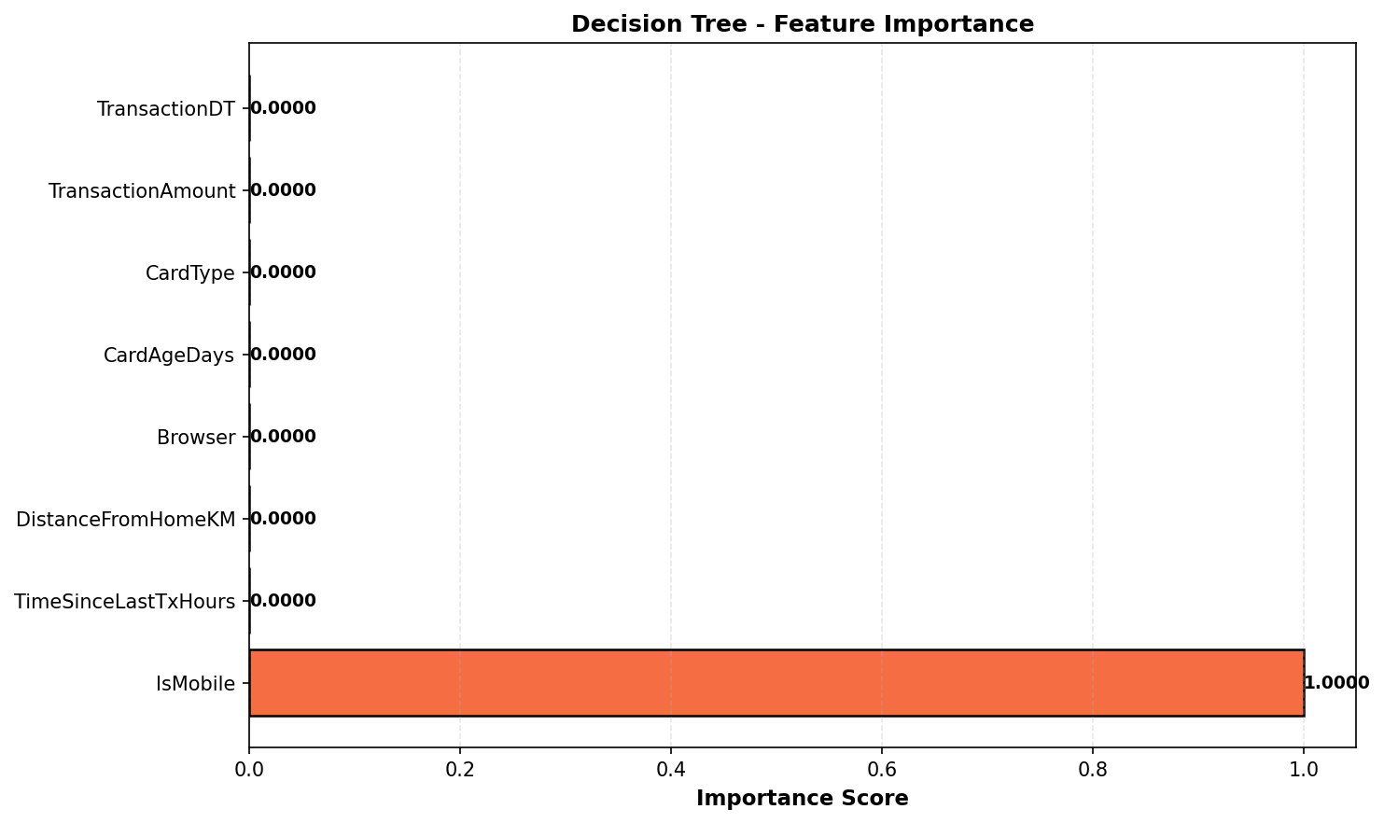
Figure 1

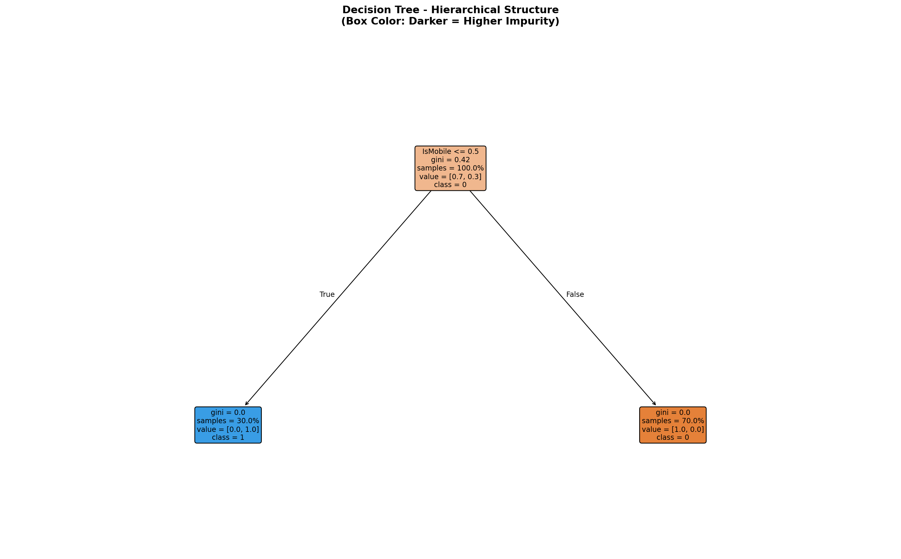
Figure 2

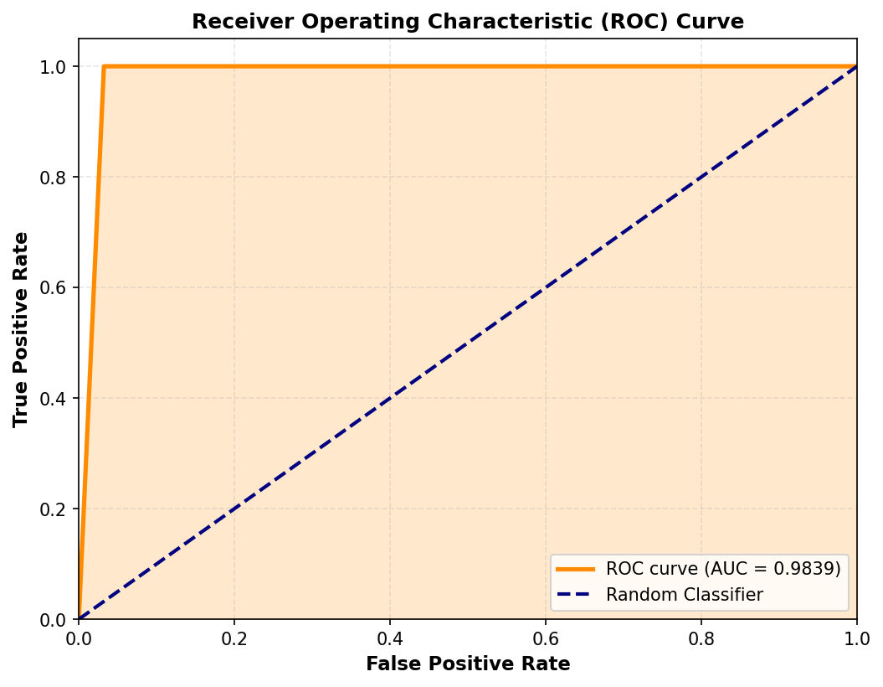
Figure 3

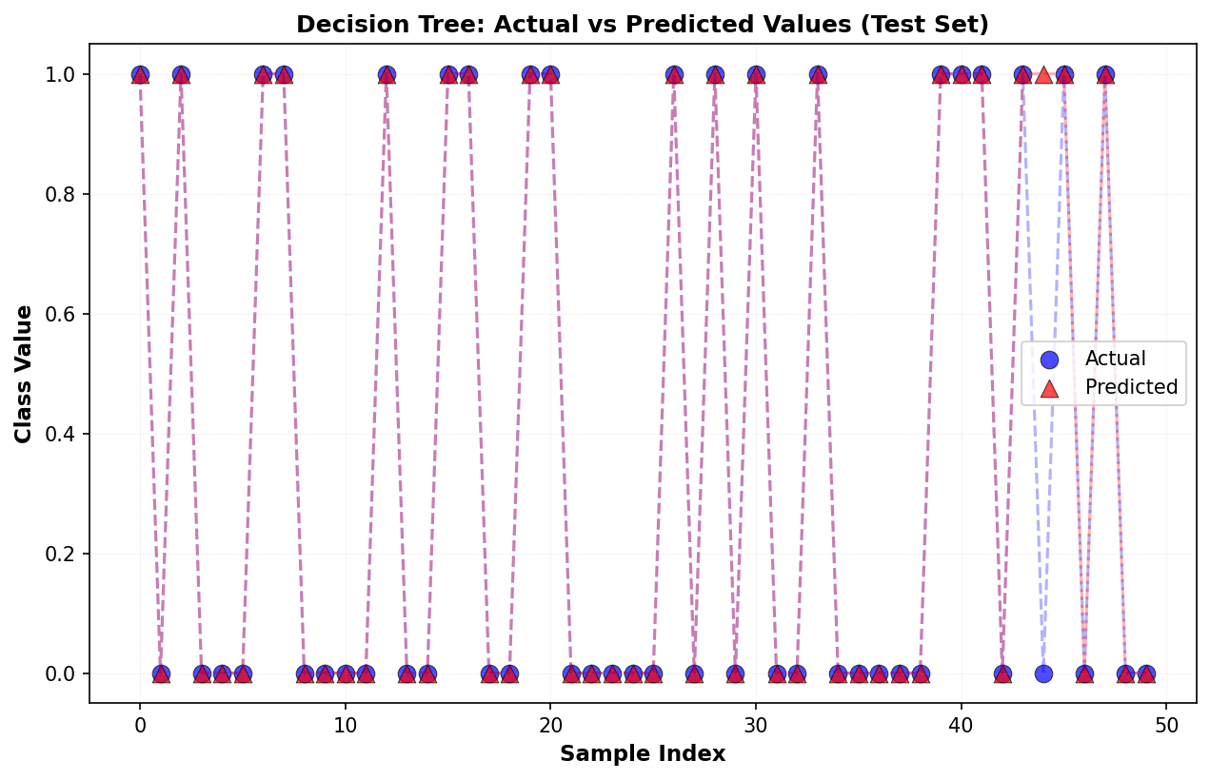
Figure 4

